The Gilded Age 6
“All that Glitters is Not Gold!” Unit 5

Most __________________ people squeezed into dark and crowded ____________, which only added to the urban problems of ____________, pollution, and ____________. Many families had to send their _____________ to work in the factories.

Working conditions
1. ___________ factories – ________ and toxic fumes; ___________ from machines
2. _________ _________ – Kids toiled long hours in factories.
3. Average worker in 1900 – 60hr work week, low pay, no insurance, no vacations, no retirement plans
4. Women – worked in ____________-related industries for _______ ________
5. _________ _________ – bosses owned ___________ and _________
– workers forced to pay _________________ and __________.

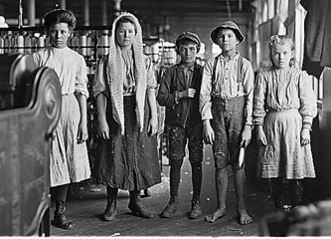

Rise of Unions
1. Labor union – _________ __________ to seek _________
________ and ________ __________
2. Unions were difficult to organize in early 1900s.
a. ________ cheap _________ gave factory owners the upper hand
b. Many _________ _____________ – hard to communicate
3. Unions used _________ to force management to listen to ___________.

Activity #1: Deciding on Demands
Imagine you are the member of a union and the union is in the process of negotiating a new contract. Rank the demands in order of importance. The first three items must include clear explanations.
________ Raise in salrary
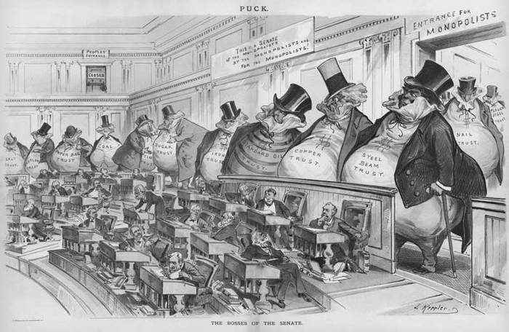
________ Better health insurance and dental benefits
________ Longer lunch time and shorter work day
________ Employees’ cafeteria
________ Larger life-insurance policy
________ Job tenure (security) after 5 years on the job
________ Daycare center for children of employees
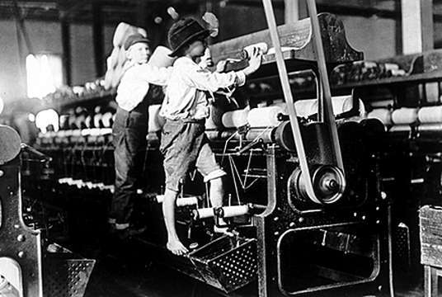

Early Unions
Knights of Labor (1869) | American Fed. Of Labor (1886) | American railway union (1893)
Allowed: ________________ (skilled & unskilled)  Advocated: end __________  labor, _____ hr days, _______  _______ for women  - Membership declined after ________________________  (7 police officers killed at a labor rally → union was __________ for violence) | Allowed: Only ____________ __________  Fought for: ________ wages and improved _________ ____________  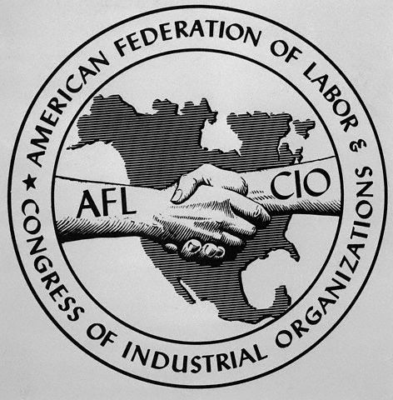  Led by ___________________ | Included: ____________  ____________  More effective - a strike could shut down the ___________  _____________  Led by __________________  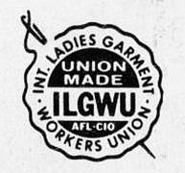
ILGWU – International Ladies’ Garment Workers Union | Comprised of ____________ ____________

Famous Strikes Description of Events Outcome
______________ Strike (1892) –  _____________ | ________ ________ - on strike after a ________ ________  -Carnegie used lockouts, scabs, & a private army | Steel _________ ________  – people afraid to join afterward
_____________ Strike (1896) –  ____________ | ARU - ________were ______ & ________ ____________ at Pullman Co. Town  -Railroad _______ _________! | Pres. Cleveland sent in _________ – _______ _______!

Outcome of labor movement
_________ _________ held the upper hand → ___________ generally taking their side.
However, the public recognized the need for a __________ between the demands of employers
and employees to avoid the numerous __________ and violence.

Antitrust Laws
____________ Anti-Trust Act | Attempted to _________ __________ from “restraining trade”
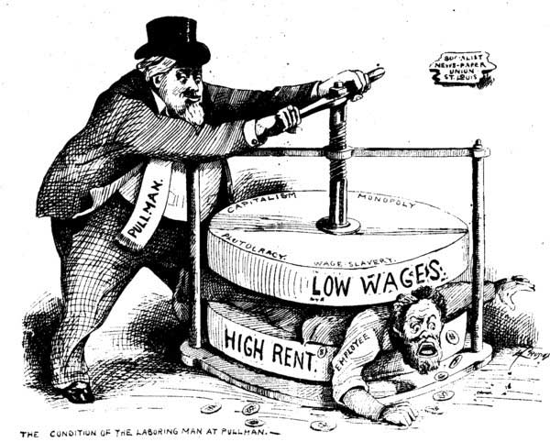  ____________ Ant-Trust Act | ___________ ________ _________and exempted Unions from being considered as monopolies

