Big Business 5
Unit 5

Introduction: The late ______________, new _____________ changed __________ _______
and influenced the __________ of __________. Labor-saving devices affected the way people
___________ and the roles they played in their _____________ and at __________.

A. By 1880s, northeastern cities had developed a modern _____________ __________. How?
1. ___________ __________ (_______________ and migration from farms)
2. Abundance of ________ ____________ (coal, iron ore, & ______) & navigable ________
3. New ________________ and ______________sped production
4. _____________ _____________ (gov’t keeps _________ _______ business) and
__________ ____________ to RR companies

Activity 1: Which comes first – the need for a new invention or does the new invention create the need? Make a list of 3 innovations which you feel are essential in you life.
- What need does this item serve?
- What did you do before you had it?
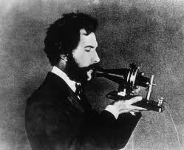
- What impact had it had on society?

B. Innovations that Improve the Standard of Living
1. Electricity = __________ __________
  - a. Developed the _________ _________
  - b. Built ________ _________ to provide ____________

- 2. Telephone = invented by _______________________________ in 1876

- 3. _____________ process = better, ___________ way to produce ___________

- 4. Assembly Line = developed by _________________ to mass-produce __________
  - a. made the _____________ (Tin Lizzie) ___________enough for many to own.
  - b. Led to ____________ and ____________

- 5. ___________ Brothers = 1st powered ___________ ___________ on Dec. 17, 1903 in
- _________ __________ , NC

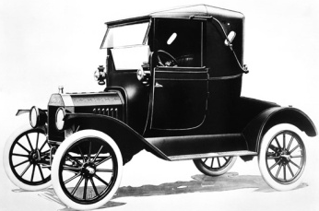

C. ____________ development brought great ___________to a few between 1870-1917. Why?
1. “Visionaries” – saw ____________ and _____________
- 2. willing to _________ ____________
- 3. Used ___________of others to organize companies
- 4. ____________ ___________ & helped to create ______________

D. Good Businessmen or Robber Barons?
- 1. Andrew ___________ = ___________ business (used the ______________Process)
- - Wrote The __________ ___ ___________ – rich have a duty to _________ ________
- (______________)

- 2. John D. _____________ = _______ _____________
  - a. Created ___________ ________ Co.
  - b. ___________ business tactics (_________ deals, deception)

- 3. J.P. ___________ = ___________
  - - owned __________, railroads, & bought out ____________

  - 4. Cornelius ___________ = _____________ business

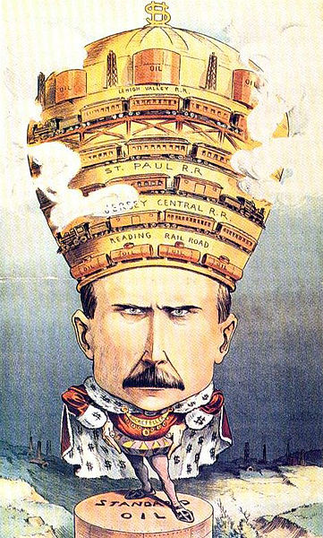

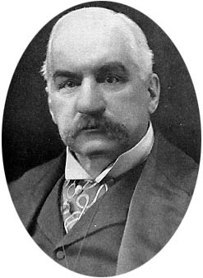

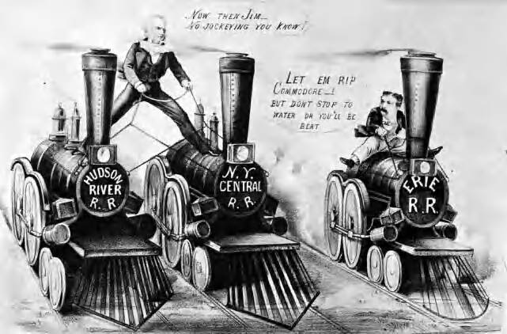

Activity 2: The growth of the factory system and big business created opportunity, jobs, and fortunes for many Americans. At the same time, the industrial giants sometimes committed cruel, unethical, and immoral acts as they built corporate empires. Do you agree or disagree with the following statements?
1. The objective of business is to make as much money as possible.
2. It’s alright for a worker to take home paper clips and other items without paying for them.
3. Poor people are poor because of their own faults.
4. The fruits of labor of millions have been stolen to build the huge fortunes of millionaires.
5. It’s alright to pay workers less then they deserve if they’re foolish enough to accept it.
6. When profits go down, companies have to lay off workers.
7. Workers should not do more than what they are paid to.
8. It’s perfectly understandable that workers slow down when the boss is out.
9. It’s alright to hire you friend as a manager even though there are more qualified applicants
10. It’s alright for a company to manufacture its products in countries where the labor is cheap in order to get big profits.

