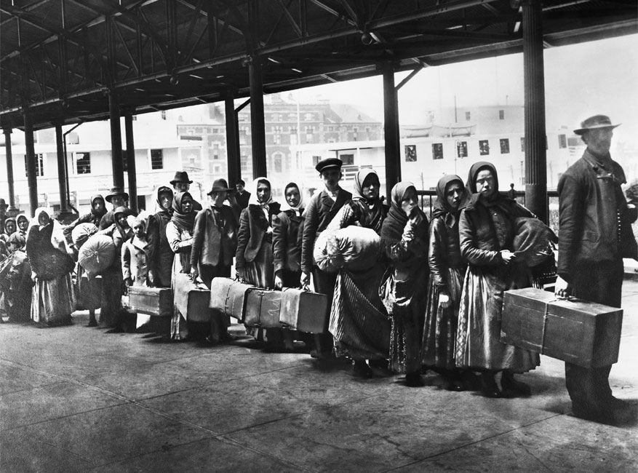
Immigration Concerns 4
Unit 5

Ellis Island
Where is it located?
Port of __________ in _______ ____________ Harbor
How long was it open?
_________ - __________
What is its purpose?
To __________ and screen _____________ before they _________ the US
How many immigrants entered the U.S. this way?
Over __________________ immigrants
Why were immigrants screened before entering the U.S.?
_____________ for ____________ and their ____________
Arriving in the harbor, what sight would they behold?
____________ of ____________, gift from ____________ in 1886
On the pedestal of this statue is a poem by Emma Lazarus which reads: “Give me your ____________, tired your __________ masses yearning to be ________…” Explain its meaning.
It is _____________ others into the United States; ____________

Immigration causes problems in Cities
Which cities grew quickly? | Why did immigrants settle in the cities? | What were some of the urban problems?
New York  ___________  Chicago  ___________  ___________ | ____________ in large  _________ provided _________, but living conditions were  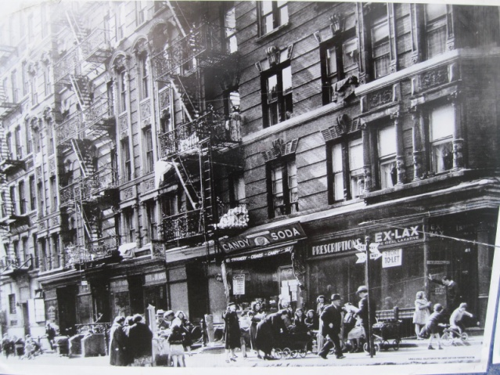  __________ | Lack of ____________ – overcrowded  ______________ & slums  Lack of ___________ services –  __________, clean ________, transportation  __________ & __________ was rampant

Which city built the nation’s first subway system?
________________ City
When? __________

Why? _________ ____________

Adjusting to life in America
Define assimilation. | __________ to and fit into new ______________
Describe the ___________  ___________ theory. | Idea that a __________ _________ of races, cultures, &  religions __________ together to form American  __________
What were __________  _________________? | City ____________ made up of a certain __________ group
Why were ___________  _______________ essential to the process for assimilation? | Immigrants learned _____________, American ____________, and became ___________

Nativist Reactions
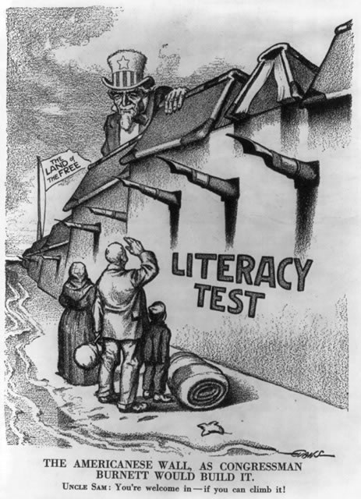
Immigrants often faced ____________ and ________________ from _____________(people born in the United States). WHY?

- __________ & sounded ___________ (languages, foods, dress, customs)
- ____________ ___________ (Jews, Catholics, Buddhists)
- Willing to work for _________ __________ (competition for jobs; lowered wages)

Laws passed to limit immigration
_____________ ____________ ________ of 1882:
Chinese were banned from the country

_____________ ____________ Act of 1921: a _________ _______ that
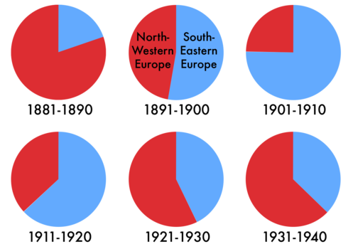
favored the _________ immigrants over the new

*These laws effectively cut off immigration
to the U.S. for the next several decades,
BUT immigrants and their descendents
continued to contribute immensely to
American society.

