Immigration to America 3
Unit 5

The history of the United States is a history of the contributions of immigrants. From the first colonists to the immigrants of today, people have been drawn to America. Throughout the 1800s, cities in the East were bombarded with new residents from foreign lands.

Old Immigrants | New Immigrants
When? – ______________  Where? – came from ______________ & _______________ Europe  Examples:  ____________ – 13 colonies  ____________ – 1840s potato _________  Germany – ____________ & farms  Norway /Sweden – __________________ | When? – 1871 to _________  Where? ___________ & ____________ Europe as  well as _____________  Examples:  Italy – _____________  Greece  Russia – ___________  ____________, Hungary, & ________________ – poor Slavic ppl.  __________ & ___________ – Hawaii & Cali.
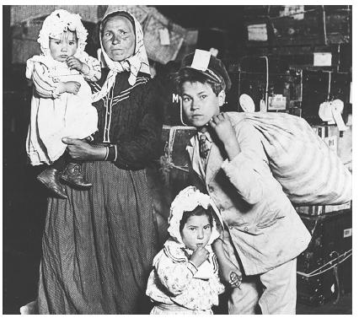
REASONS FOR MIGRATION
Why did people leave their home countries?
______________ persecution
________________ or ___________
________ & ____________ persecution

What are some reasons why immigrants would be __________ to America?
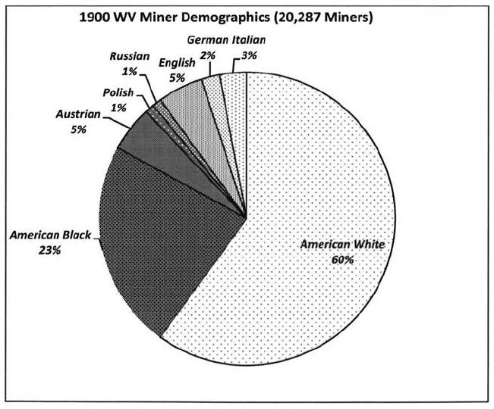
Promise of _____________
Availability of ____________/____________
___________ & ___________ in US

How did immigrants contribute to America’s industrial growth?
1. _____________ workers helped build the _______________ RR
2. _________, Italians, & __________ worked in __________
____________ of the East
3. Worked in the __________ & __________ mills of the ____________ cities

“I came to America because I heard the streets were paved with gold. When I got here, found out three things: First, the streets weren’t paved with gold; second, they weren’t paved at all: and third, I was expected to pave them.”

