The Wild West 1
Unit 5

Following the_________ _______, settlers streamed into the lands between the Mississippi R. and the Rockies, better known as the __________ __________. WHY?

A. Many ___________and __________ took advantage of the ____________ _______ of 1862.
1. Federal govt offered ______ ________ for _________ – had to live on & farm the land for 5 years.
2. Difficult life (few _________, limited ________, extreme temps.)
3. _____________ (built houses out of chunks of _________) often lost homesteads b/c of
drought, ____________, & overuse of the land

B. New _____________ made farming on the Great Plains ____________
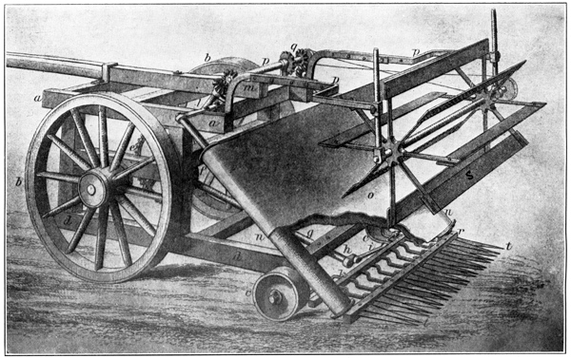
1. ____________ ___________ = a _____________ machine to cut _________ and corn more efficiently
2. Railroads linked __________ and ___________
- opened lands in the ________ & encouraged ___________.

C. Raising _________ leads to the era of the ___________
1. Huge __________ for __________ in the Civil War
2. RRs shipped the meat __________
3. _________ _________ = cowboys herded Texas __________ to RR in _________
4. “_________ ________” – cheap _________ to protect ___________ from cattle herds

E. In 1890, the __________ Bureau reported there was _____ ________ __________ left
F. Conflict with the American ___________
1. Indians pushed onto ____________ - deprived of hunting grounds for ____________
2. U.S. govt ________ _________ with the Indians & had little respect for their ________
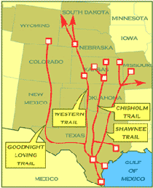
3. U.S. plan to ____________ the Indians __________!
