The End of Reconstruction 7
Unit 4
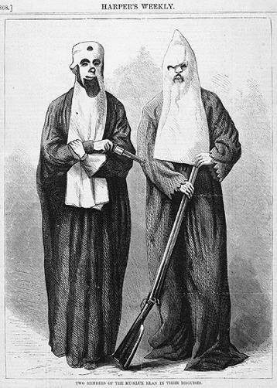
What political party did former Confederates join?
  - Democratic Party
What was the major goal of the KKK (Ku Klux Klan)?
  - terrorize blacks by kidnapping & hanging
  - prevent blacks from voting for Radical Republicans

Election of 1876:
1. Who were the candidates? Parties?
- Rutherford B. Hayes (Rep) vs. Samuel Tilden (Dem.)
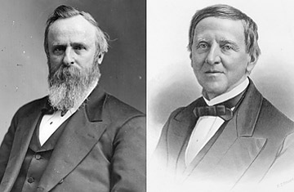
2. What was disputed in the election?
- electoral votes
3. Who decided the election?
- A commission set up
4. What was the outcome?
- Hayes got all of the disputed electoral votes
5. Who was angered by the outcome?
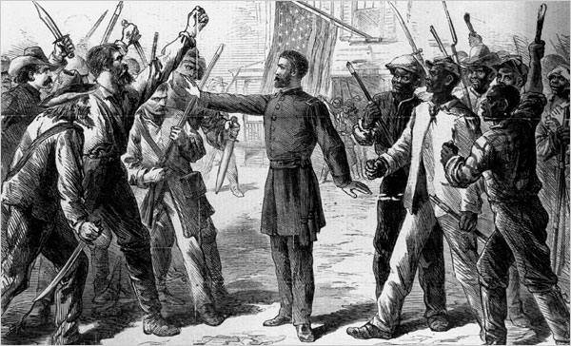
- Southern democrats agreed to a compromise
COMPROMISE of 1877 ended Reconstruction
- Hayes would be president if military occupation of the South ended
- Withdrawal of federal soldiers = Reconstruction ended

The purpose of the Black Codes
- restrict freedoms of blacks and make them 2nd class

“Jim Crow” laws legally segregated blacks from whites in daily life.
Examples: Schools, bathrooms, hospitals, buses, churches, cemeteries

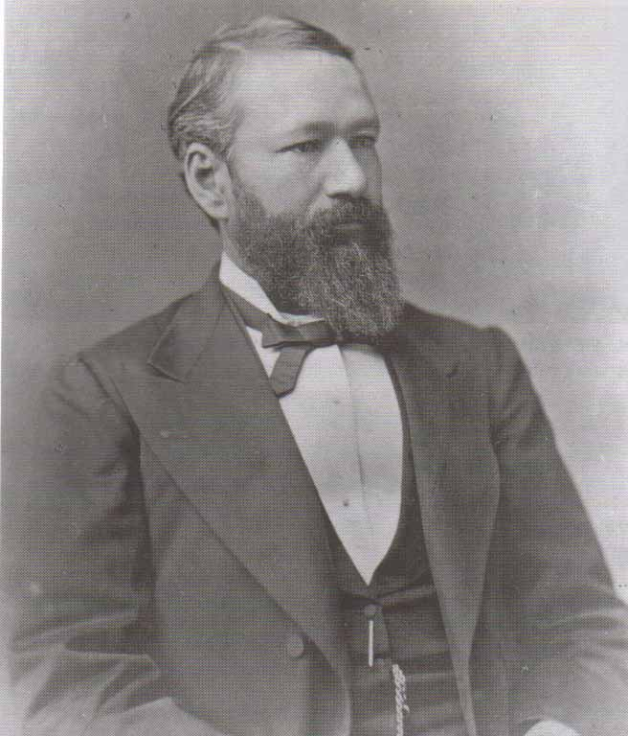
The case of Plessy v. Ferguson (1896):
1. Why was Plessy arrested? - He was sitting in the white first class
2. By Louisiana law, what was his race? - Black (1/8)
3. Which amendment did he use to defend himself? - 14th Amendment

How did the Supreme Court rule in the Plessy case?
- Segregation was legal if both races had equal facilities
– “Separate, but Equal” does not violate the 14th Amendment

