“Plans for Reconstruction” 6
Unit 4

Lincoln’s Reconstruction Plan – Used by Andrew _____________
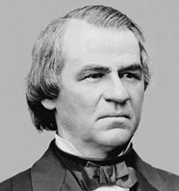
- Lincoln’s goal: Restore ___________ _______________
- Secession was _____________ = Confederates _________ _______ the Union
- ______ of the voters in each state had to swear _________ _______ to the Union
- States had to ____________ ____________
- President Andrew Johnson ______________ the plan

The ______________ Republicans
- believed in the _________ & __________ ___________ for African Americans
- ______________ lenient plan – wanted __________ ______________ for the South

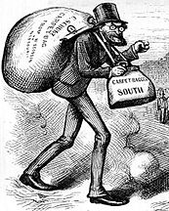
Radical Republicans’ Plan (1867)
- Divided the South into _____ ___________ - under __________ _________
- A _____________ of ex-Confederates in each state had to ________ __________
- Each state had to give ___________ the right to _________

Radical Republicans Impeach President Andrew Johnson
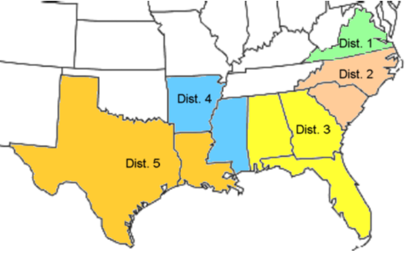
1. Why didn’t the President and Radical Republicans get along?
- Had __________ ideas on __________ __________ for freed slaves
2. Who did the President fire from his Cabinet?
- Edwin ____________, Sec. of __________ (Radical Republicans)
3. What law did he violate?
- Johnson __________ a cabinet member w/o the _____________ consent
4. What was the outcome of his trial?
- He was ______________ by the House of Representatives
- Senate was ________ vote _________ of removing Johnson from office

Civil Rights Amendments Passed During Reconstruction
_______ Amend. (1865) | _______ Amend. (1868) | _______ Amend. (1870)
– _________ all slaves and  ______________ slavery | – Former slaves are ___________ & obligated the states to protect their ________ | – Guaranteed ___________ rights

