Life after the War 5
Unit 4

__________________ = period _________ the Civil War (_______________)
- Americans struggled to ____________ the ___________ and recognize newly ________ ____________ and their place in society.

Compare the Impact of the Civil War
South  - _______________ devastated  - _________, RR, & _____________ destroyed  - Many ________ lay in ___________  - remained ____________ & _____________ for decades  - Southerners ____________ their treatment by  the ____________ | North  - Powers of the __________ gov’t ___________  over the power of the ___________  - Emerged with ___________ and growing  ______________  - Completed the ______________ __________  which intensified ______________ movement  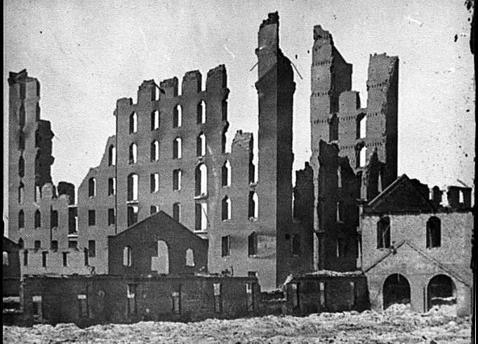

African-Americans after slavery was abolished?
- Families ____________
- Sought _____________ & privacy
- Headed to Great ___________ & ______________ cities

Role of the ______________ ______________ in the South (1867)
1. Helped _________ ___________ adjust to __________ after the Civil War
2. Services and accomplishments:

a. Gave ___________ and ____________
b. Set up _____________
c. Provided ___________
d. Created ____________ to train black teachers
e. Negotiated fair __________ __________

POST-WAR CONTRIBUTIONS:
Ulysses S. Grant – _______ President
- Supported __________ for ___________ and opposed ___________ ___________ of ex-Confederates
Robert E. Lee – Urged the South to reconcile – ___________ of ________________ College
- Believed ______________ is the key to a ___________ ___________
Fredericks Douglas – Advocated ___________ for blacks and encouraged the Federal
government to ___________ their ___________
- ambassador to _____________

