The War’s End (1865) 4
VUS.7 a,b Unit 4

A. African-American Contributions
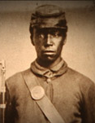
1. After the _____________ Proclamation, _______,000 blacks served in the _________ army
2. Frederick ____________ urged Lincoln to use former _________ &
________ __________ in the Army
3. The __________ refused to use slaves as soldiers

B. Grant Defeats Lee
1. ____________ S. _________ was given command of the __________ army after
winning key battles in the _________
2. The North engaged in “________ ______” - burning _________ property & crops
3. Grant did not allow the Confederates to __________
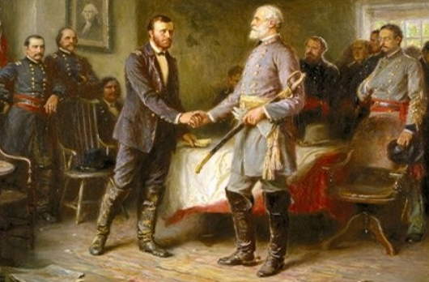
4. After losing ___________ & Petersburg, Lee was cut off at _____________, VA
- Lee ____________ on April 9, _________

C. Lincoln’s Death
1. __________ believed the country needed to be ___________
a. He did not want to __________ the _________
b. 2nd ___________ Address - Lincoln said, “with _______ _________ ________,
with ____________for ________, let us…bind up the _________ _________”
2. April 14, 1865 - ________ ________ ________, a popular actor, ________ Lincoln at _________ Theater
3. ___________ ___________ (TN) - became the _______ president
