**KEY EVENTS of the CIVIL WAR** **3**

[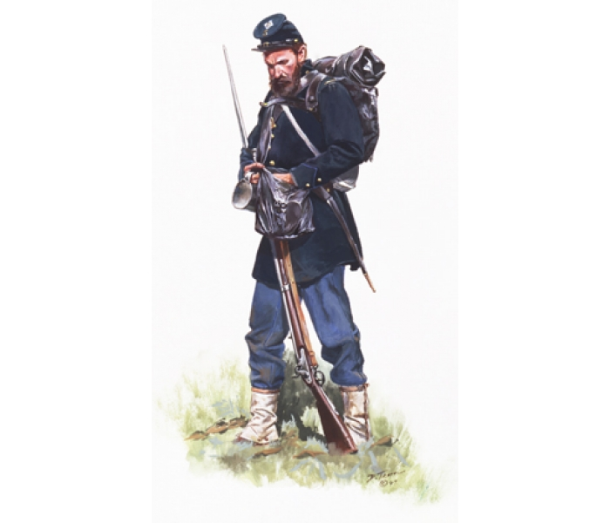](http://www.google.com/url?sa=i&rct=j&q=&esrc=s&frm=1&source=images&cd=&cad=rja&docid=DBlWUFnpq4qpKM&tbnid=GzBXUEWJELUYXM:&ved=0CAUQjRw&url=http://www.historicalartprints.com/store/index.php?route=product/product&product_id=366&ei=33tUUoefMOih4AOJ-4D4CQ&bvm=bv.53537100,d.dmg&psig=AFQjCNEy6n3xmO2VXaIcCD_HCcgCk_TLXg&ust=1381354823318419) Unit 4

**Apr. 1861: Fort ____________ (_____)**

- ___________ _______________ of the war

**Sept. 1862: ______________ (MD)**

- Lee tried to ___________ the ________ to gain a foreign _____________ with France

- Single ___________ ________ of the war (22,000 casualties)

- _________ victory = allowed Lincoln to pass the ___________ ____________

**________________ Proclamation**

- Lincoln ordered all “slaves in ____________ ___________” be set __________ on Jan. 1, 1863

- Made ___________ of _________ a goal of the war

- Discouraged ___________ ____________

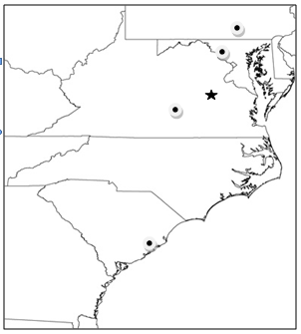

**July 1863: _______________ (______)**

**– _____________ POINT!**

- Lee’s 2nd __________ of the North _________

- After 3 days of fighting, Lee lost _____ of his army

- __________ army began __________the war.

**Gettysburg _____________; Nov. 1863**

- Lincoln’s speech to ____________ the ___________

-referred to the ___________ of ____________

- Civil War is being fought to:

1) ____________ the ____________ (“…that government of the people, by the people, for the people”)

2) _________slavery (“…the proposition that all men are created equal...”)

[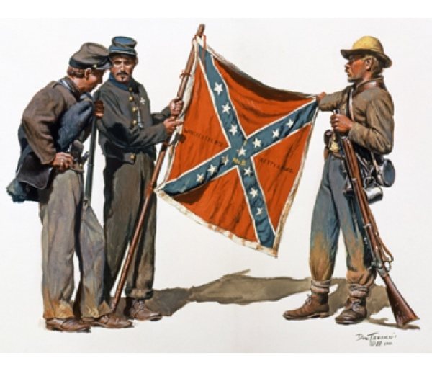](http://www.google.com/url?sa=i&rct=j&q=&esrc=s&frm=1&source=images&cd=&cad=rja&docid=ewXdx48C9QbdxM&tbnid=LX94Sf0lCY6gnM:&ved=0CAUQjRw&url=http://www.historicalartprints.com/store/index.php?route=product/product&product_id=58&ei=VnhUUquHIKfA4APwgoG4DA&bvm=bv.53537100,d.dmg&psig=AFQjCNEMmrAADODZmrBNzTFI8ELdR2fvsQ&ust=1381353910563353)

**Apr. 1865: ______________ (_______)**

- Lee ______________ to __________, ending the war