VUS.7a,b The War Begins (1861) 2
Unit 4

A. Opening Confrontation at Fort Sumter (Charleston, SC. – April 1861)
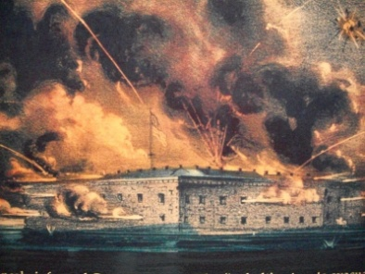
1. South fired on the fort & captured it
2. Event stirred nationalism in the North & the South
a. Lincoln called for 75,000 volunteers to put down the rebellion.
b. Davis called for 100,000 troops to defend the south

B. More Slave States Secede
1. Lincoln’s call for troops caused VA, NC, AR, and TN to secede
2. MD put under martial law by Lincoln to protect Washington, DC
3. Robert E. Lee = was asked to command Union army, but he rejected it
a. opposed secession
b. could not fight against his family & his beloved VA
c. Became Confederate general of the Army of Northern Virginia

SOUTH  1. Fighting on their land  2. Better generals  3. Lack of supplies & $$  4. Lower population – would not use slaves  Confederacy, Rebels, Gray | NORTH  1. Larger population  2. More money & factories  3. More RR to move supplies  4. Kept border states in Union  Union, Federals, Yankees, Blue
C. Comparing Resources

D. Realities of War
1. Soldiers used old tactics with modern weapons = high casualties
a. kept diaries & wrote letters home to fight boredom
b. Poor medical practices led to amputations
c. 620,000 deaths - most were caused by diseases
2. Women ran the farms, worked in factories, & managed the families
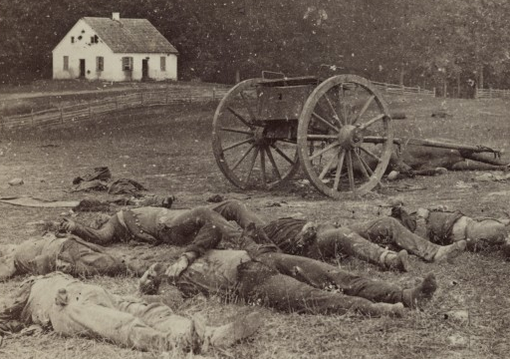
- Many became nurses to care for soldiers

