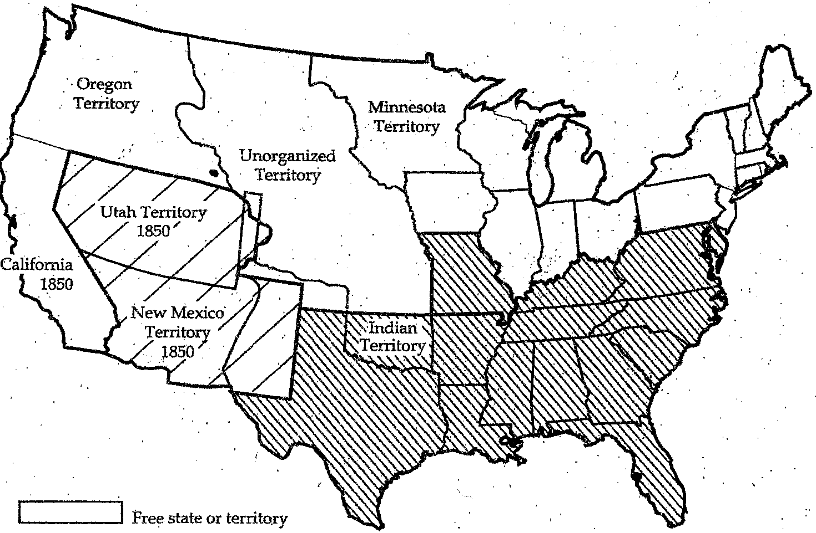
Sectional Tensions 1
Unit 4

A. Compromise of_________
1. 1849 - _______was discovered in ____________
a. Within a year, the ____________ reached 90,000
b. Wanted to be a _________ _________
2. Deal:
a. ______- free state
b. _____ & ______ allowed to ___________ if free or slave
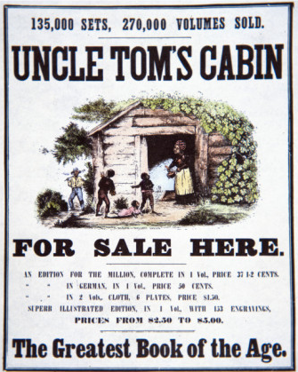
c. Stricter _____________ ____________ law
– forced Northerners to ___________ ____________

B. ________ _________ Cabin (1852)
1. written by __________ ___________ __________ - abolitionist
- Fictional account of the __________ of ___________
2. South – very _________ & defensive

C. Kansas-____________Act (1854)
1. Sen. __________ ___________, (IL), proposed new territories
- ___________ & Nebraska
- abolished the ____________ Compromise
- let the __________ ________ on the slavery issue – ____________ ____________
2. Northerners formed the __________ Party – opposed __________ of slavery

D. Bleeding ____________ (1856)
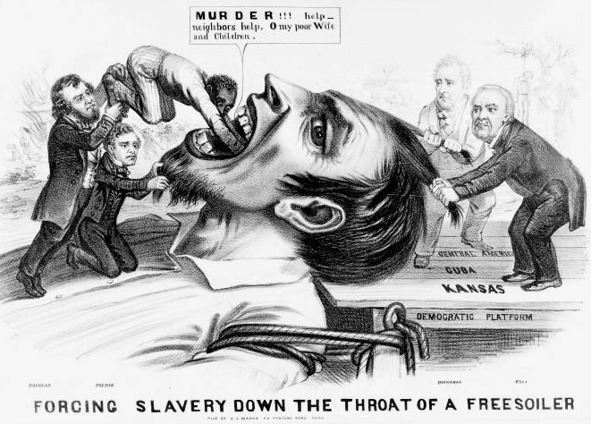
1. Because of popular sovereignty, there was a race by _________ ____________ & _______________ to ___________ Kansas
2. ________________ left hundreds dead

E. _________ ___________ Decision (1857)
1. Scott _________ for his ___________ b/c he had lived
in a __________ state
2. The Supreme Court ruled:
a. _____________ were NOT ____________ & could not sue
b. Congress could NOT __________ ___________
3. __________ loved decision; Northerners were outraged!

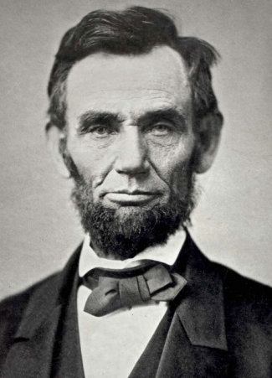
F. Election of _________
1. _________ __________, a Republican, won the electoral majority; but only
_________ of the ___________ vote
3. Southerners hated Lincoln – “A __________ divided against _________ can
not _____________.”

G. Secession & States Rights
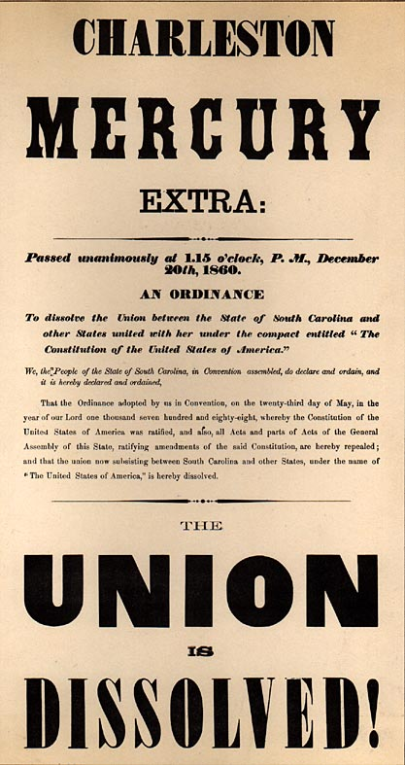
1. Thinking President Lincoln would _________ the ____________ – southern
states began to _____________ (leave the Union)
2. Southerners believed in ____________ ____________ – states could ___________ the union if they wanted
- formed the _____________ ____________ of America
- ____________ ___________ (MS) elected President
3. Lincoln asserted: “No ________ may leave the __________ after it has joined”; “The United States is __________ ___________, not a collection of __________.”
