“Territorial Expansion” 9
VUS.6a Unit 3

A. __________ Destiny - Americans believed U.S. should stretch from __________ to _______
1. Led to conflicts with _________ and the __________
2. Growth of _______ & __________ helped westward flow of __________.
B. Reaching Oregon
1. Many settlers traveled ________ on the __________ __________
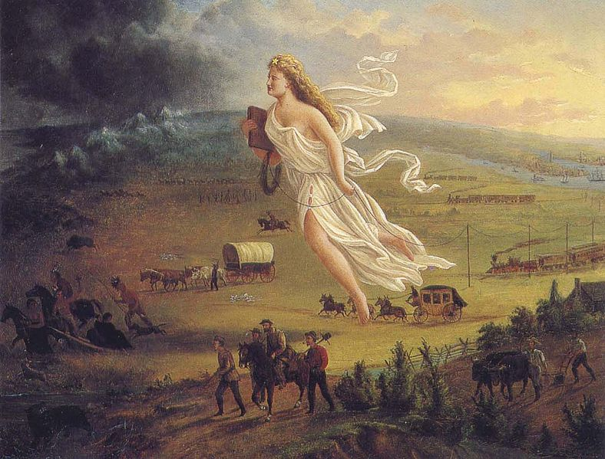
2. Treacherous journey - crossed the ___________

C. Texas (1836)
1. __________ won its independence in ________
- Allowed _____________ into _______
2. War: _________ - 188 Texans fought to the ________ ________ - killed by Mexican army
- __________ later defeated Mexico & won ____________
3. TX became the ________ _______ ___________
4. 1845 – TX became a __________
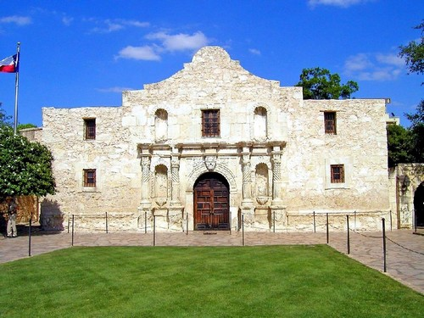

D. The Mexican War (1846-1848)
1. President James K. __________ wanted _____________
- Annexed ________ in 1845 & gained __________ in 1846
2. Fighting broke out w/ ___________
3. Mexico ______________
RESULT – U.S. gained to the Rio Grande River, _____________, & the _______ ____________ territory (_____, UT, _______, NM, _______)

