Reform Movements 8
VUS.6e Unit 3

A. The conflict over ________ threatened to tear the country _______.
- ____________ sought to get ______ of slavery.
1. ________ Lloyd __________- Published ___________ newspaper called “The ___________”
-Slavery was against ____________ ___________
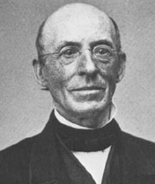
2. __________ ___________, former slave who escaped
a. Powerful ___________
b. spread the message that ____________ was ________
3. Abolitionists helped slaves escape via the ____________ _____________.
- ____________ leading slaves to ____________
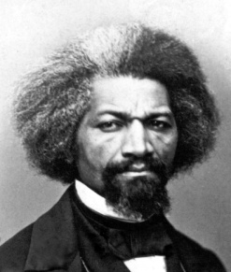
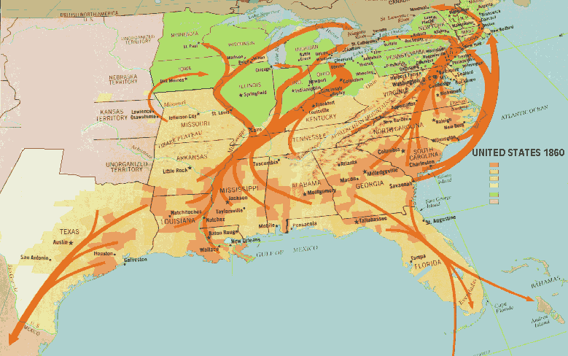

B. Southerners felt their _______of _________ was ___________.

C. Slave Revolts
1. In 1800, ________ _________ planned to capture an _______ and ______ slaves
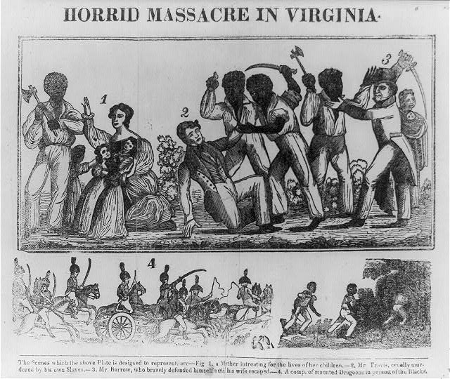
2. In 1831, _______ __________ killed 60 whites near Hampton, VA
3. RESULT: the South imposed _________ fugitive _________ laws

D. Women’s Rights
1. In 1848, women gathered at the _________ ________
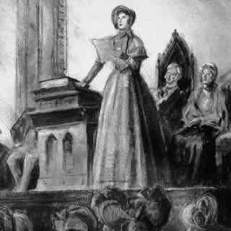
Convention ( NY)
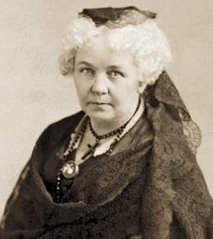
a. Organized by _________ ________ ___________
b. Wrote a ____________ which stated
that “All _______ and __________ are created __________…”
-modeled after the Declaration of _______________
c. Many women continued to fight for __________

