Growing Differences 7
VUS.6 Unit 3

A. The Industrial North
1. The North developed an __________ economy
a. _____________ – cheap labor
b. Railroads & canals - ______ goods & ___________
2. Factories produced ____________ (cloth)
3. Favored ________ tariffs (tax on __________)
4. Did NOT rely on __________

B. The Agricultural South
1. In 1793, ______ __________ invented the ________ ______
a. Clean ________ from raw cotton ________
b. RESULT – Slavery __________ – needed to ________ & __________ more cotton
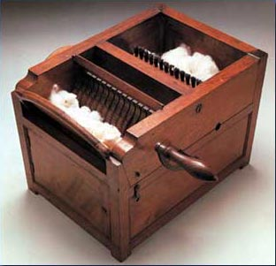
2. “Cotton Becomes _________!”
a. “Deep South” (_____, AL, ______, GA, & ______)
= major cotton states
b. Slavery became a “__________ ________”
4. ___________ high tariffs – made imported goods ___________
5. Wanted to ________ slavery in _______ states

C. Missouri Compromise of 1820
1. _________ wanted to enter as a _______ state
- would upset the _________ in the ________ (11 free & 11 slave)
2. COMPROMISE:
a. Missouri added as a _______ state
b. ________ added as a _______ state
c. In new territory, slavery would _______ be allowed above __________ line

