The Common Man 6
VUS.6 D,E Unit 3

A. Controversy in the __________of _________
1. Jackson won the most __________ votes, but NOT an ___________ __________
2. John _________ ________ became president – “Corrupt __________”
3. Jackson formed the “____________ Party”

B. Election of 1828
1. Franchise Extended = eliminated __________ requirement to vote
– ________, white men could vote – _______as many ________ in 1828
2. Jackson = the “__________ _______
3. Jackson became the ______ President

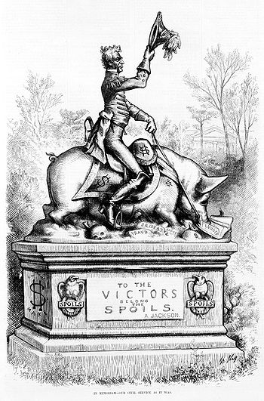
C. Jackson Takes Office
1. __________ _________ = give jobs to loyal party _________
2. “Democratic” beliefs – _______ (white, male) citizen should ____________ in gov’t
3. “King Andrew” – criticized for using ________ ___________ too often
-_____________ the __________ of the United States

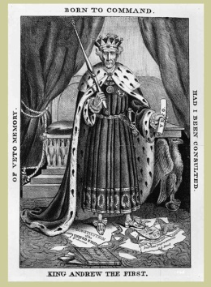
D. Nullification Crisis
1. SC upset by ________
2. V.P., John Calhoun offered idea of ____________
– states can ___________ a federal _________
3. Jackson threatened to send _________to collect the tax
4. A ________ was negotiated
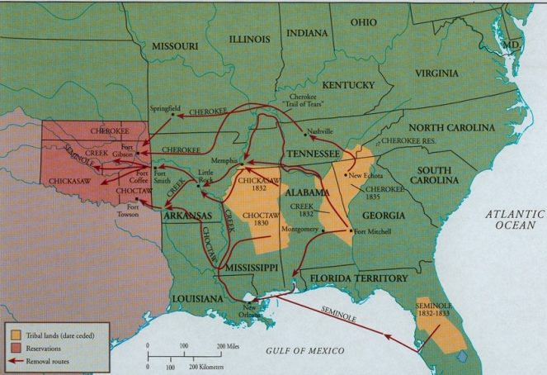

E. Policy Towards Indians
1. In 1830, govt. forced _________ to __________ to Oklahoma
2. _________ of _________ (1838-1839) – about 4,000
Cherokee ________ during __________ from GA to OK
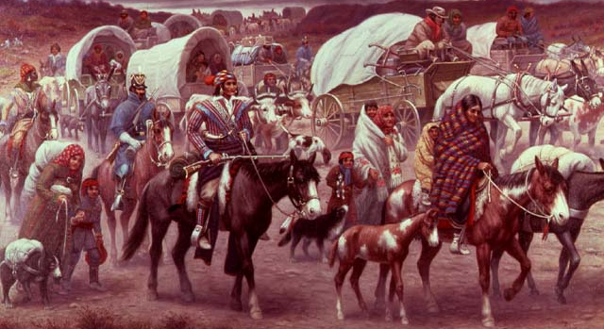

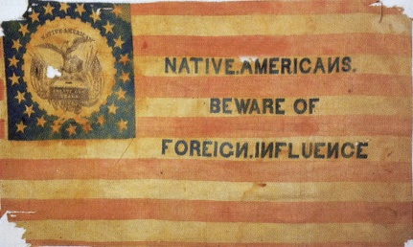
F. Formation of New Parties
The ____________ Party ____________ & new parties formed:
1. ________ = favored ____________ & commercial development
2. _______________ = hated Catholics & _____________

