GOOD TIMES 5
1816-1824 Unit 3

A. James Monroe: _____ President – ______________________ from ______________ County
-“Era of Good Feelings” = intense ______________ (patriotism) after the War of ______

B. Improvements in Transportation
1. ________ = National Road built from ______ to ______
– helped settlers ________ __________
2. Canals = __________ larger bodies of water
3. ___________ (1807) made travel _______ & cheaper
4. Railroads = much __________
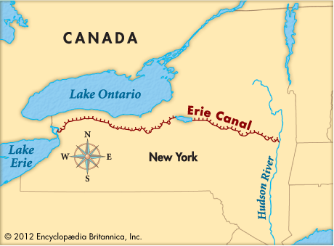
- Connected NE __________ to ___________ in the west
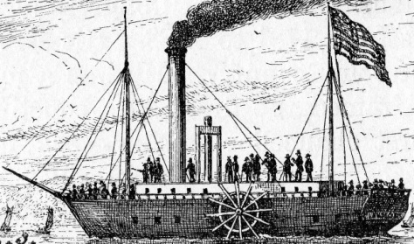

C. Monroe Doctrine (1823)
1. _________ American nations ___________ against ___________ rule
a. Americas should ________ be ____________ by _____________ powers
b. If Europe interferes with any _______ _________ in the Western Hemisphere, the ______ will regard it as a _________
c. U.S. will not __________ in European _________

