Madison & the War of 1812 4
Unit 3

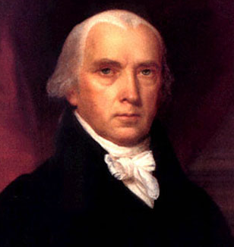
A. Causes of the War
1. _________ and _________ were fighting again!
– U.S. tried to stay __________.
2. British __________ with U.S. ___________ and western _____________

B. War ___________(wanted to fight)
1. ____________ = easy target
2. Federalists ___________ b/c they ________ w/ Britain - “Mr. Madison’s War”
C. The War
1. In 1814, ________ ________ key cities – DC, Baltimore, & New Orleans
2. Aug. 1814: Redcoats _________ the __________ Mansion & the __________
3. British were turned back at ____________
- Ft. McHenry - ___________________ wrote our national anthem, “The ________________ Banner”
4. British failed to capture ______________ in Jan. 1815
a. ________________ (TN) became a hero by defeating the British army

D. Results of the War of 1812:
1. Americans claimed the ___________________
2. Americans migrated into ___________
- __________ ceded (gave up) __________ in a __________.
