Democratic-Republicans 3
VUS.5E, 6A-D Unit 3

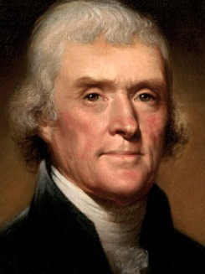
A. Thomas Jefferson: ______ President (1801 – 1809)
1. ________________ Man – a man of many talents
-Founded _________ (public university)
2. Goals: _________ __________ & _________ of ________

B. Louisiana Purchase(________)
1. ___________ sold _____________ Territory for ____________
2. ___________ the size of the U.S. and its ________ _________

C. Lewis and Clark (1804-1806): ___________ the Louisiana Territory
- ______________ = Indian woman; guide & translator (& mom)
1. Searched for a ___________ to the Pacific
2. Observed customs of the __________ __________
3. Took notes of the _________, weather, _________, & animals
4. Claimed __________ ___________ for the U.S.
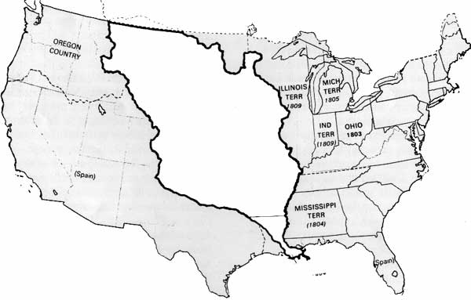
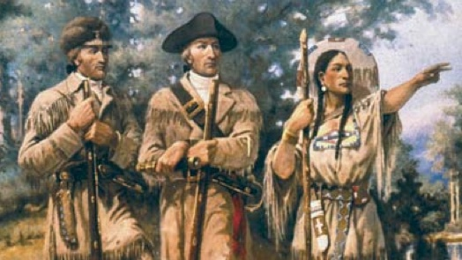

D. Chief Justice ________ ______________
1. Strengthened the Judicial Branch
2. Marbury v. Madison (1803) = established power of ___________ ___________
a. ________ _________ can declare laws “_______________”
b. __________ Branch can _________ the power of the other two branches
3. McCulloch v. Maryland (1819) = _______ taxed the Baltimore branch of the _______
a. Ruling – States _____ ______ tax the federal gov’t
b. Reinforced federal govt.’s __________ __________ to create the bank
4. Gibbons v. Ogden (1824) = ___________ clause
Ruling – __________ gov’t has the power to ________ interstate __________

