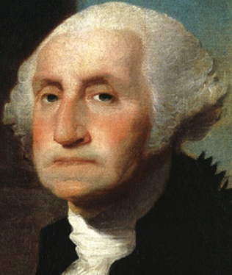
The Rise of Politics 2
VUS.6a Unit 3

A. 1st President (1789: NYC)
- Washington was the __________ choice – hero of the ____________
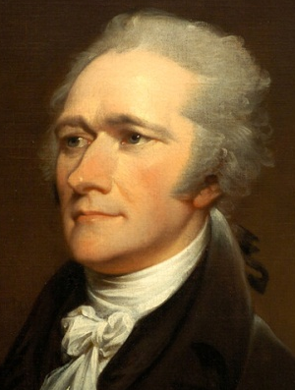

B. Big Problems
1. U.S. owed $54 million(war ________)
2. ___________ ___________ (Treasury) believed the U.S. should:
a. Establish a ____________________________________ (BUS)
b. Help the ________ pay off their _________

C. Jefferson Opposed ____________ Policies
- _____________ does NOT give the ___________ to create a bank
a. Hamilton justified the BUS with the “__________ __________” (I.8.18)
b. Jefferson ___________
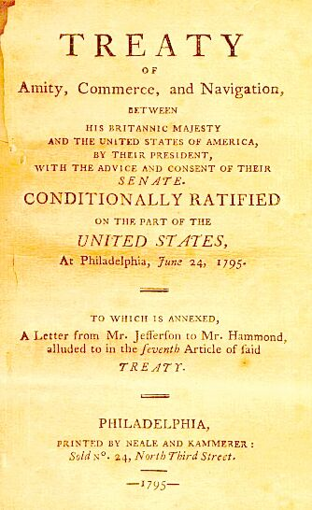
- led to the birth of the first _________ ___________

D. Foreign Policy – ___________
1. In 1793, __________ & __________ started another war
2. U.S. tried to remain __________
3. Jay Treaty = U.S. was given ___________ rights w/ __________
- Very unpopular, but it __________________!

E. Washington Steps Down
In his ___________ ___________ (1796), he offered the following advice:
1. NO involvement in ______________________
2. NO “_____________________”
3. NO _________________
4. NO __________________ (East vs. West, North vs. South)
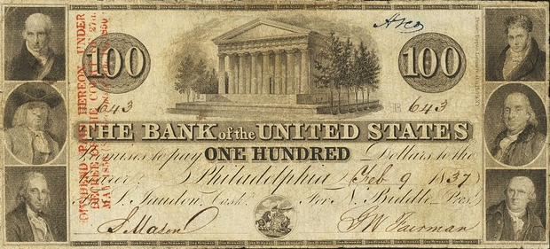

The First Political Parties | Federalists | Democratic-Republicans
Leaders | -John ____________  -Alex ____________ | -Thomas ____________  -James ___________
Beliefs | -____________ national gov’t  -Growth of ______________&  ______________ | -__________ national gov’t  -___________ need more power  -Growth of _____________
Supporters | -____________ and Businessmen in the ____________ | -____________, Artisans, and Frontiersmen from the ___________
G. Election of 1796 (First ___________ election)
1. ______________ did not anticipate political parties.
2. John __________ vs. Thomas ___________
a. ___________ won
b. Jefferson became ______________

H. Adams’ Troubles
- French agents (XYZ) wanted __________ from the American delegates
a. An __________ __________ ________ erupted w/ France
b. _____________________ criticized Federalist foreign policies

I. Election of 1800: Rematch – ____________ defeated Adams
- 1st peaceful ___________of __________ from one party to another

