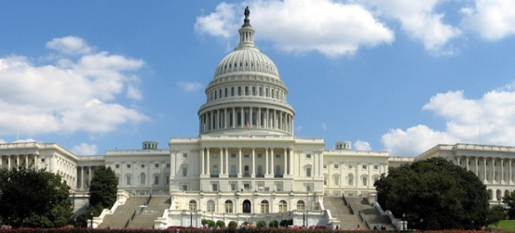
The Power of Compromise 10
Deals made at the Constitutional Convention Unit 2

A. James _________ suggested the ________ ________
1. Divided govt. into _____________ – ___________ powers so no one branch became too _______________
2. ____________ ___________ branch = 2-houses
3. _____________ based on ____________ of the _______ (favored _______ states - VA & NY)

B. States with __________ populations liked the ________________
1. Each state = _________
2. ______________ would be _________ (favored smaller state like DE & RI)

C. The _________ ____________ solved the problem
1. __________ of ______________ – representation based on _____________
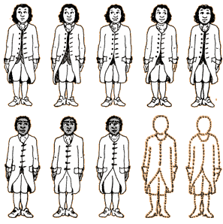
2. __________ – representation is _________ (____ senators per state)

D. _______________ Compromise = solved the ___________ problem
1. __________ – wanted slaves to count toward _____________.
2. __________ – wanted slaves _________
3. Compromise: ___________=___________ for representation
& taxation

E. Legislative Branch given new powers!
1. Levy & collect ________
2. _______ ________
3. Regulate __________
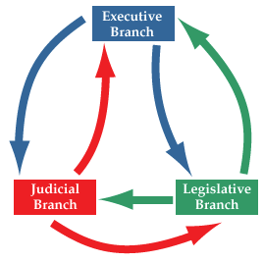
F. Executive Branch = to prevent ______ _________ from becoming too powerful:
1. The _____________ serves ________________ & runs for re-election
2. Chosen by ___________ ____________

G. Judicial Branch = created the __________ ___________

H. Framework for ___________ ____________
1. _____________ = national government _________ powers with the states
2. _________ & _____________ = prevent too much power
3. ______________ = add or make changes to the Constitution
4. __________ _________ = federal law is the “_________ _________ of the land”

